**USPOREDBA KNJIŽEVNOG DJELA S NJEGOVIM PRILAGODBAMA U DRUGIM MEDIJIMA**

**„Charlie i tvornica čokolade“**

Slika na kojoj se prikazuje tekst, snimka zaslona, krug, dijagram

Opis je automatski generiran

<https://www.youtube.com/watch?v=2-fWqIYEnRU>

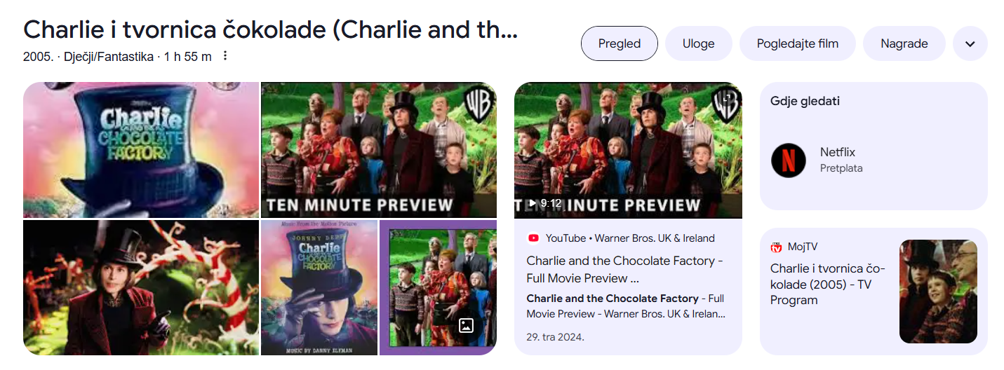

**Tito Bilopavlović: „Paunaš“**

Film učenika Osnovne škole Ivanovec (2011.)

<https://www.youtube.com/watch?v=2nbZDEOLGZ4>

ili

Film učenika Osnovne škole Ludina (2016.)

<https://www.youtube.com/watch?v=jJSJVMvaLA0>

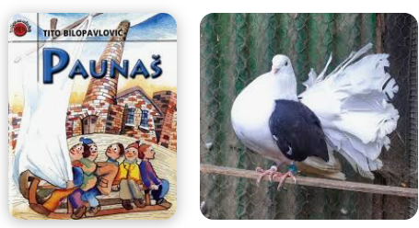

**Ivana Brlić Mažuranić: „Priče iz davnine“**

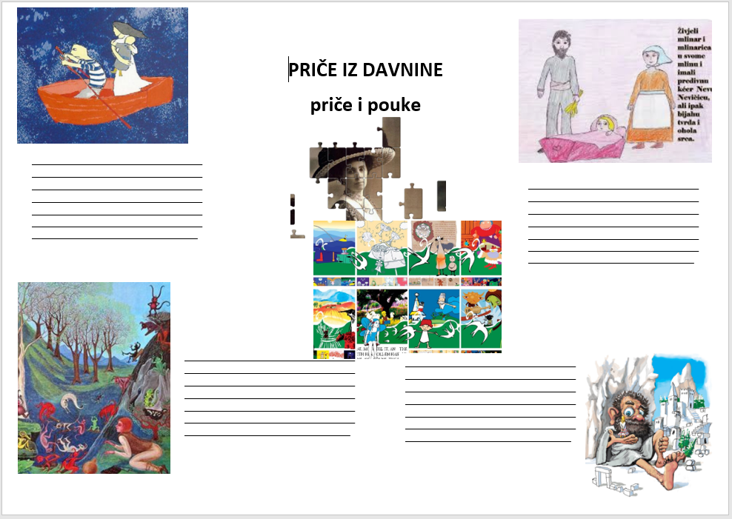

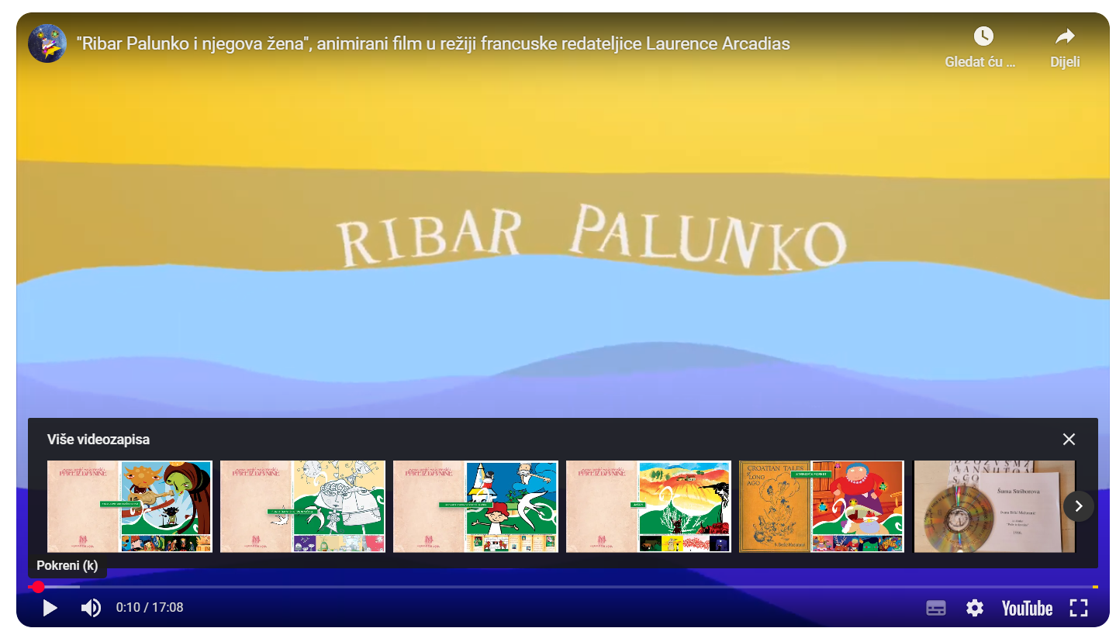

[**https://www.youtube.com/watch?v=2n_Nv5VGH-4**](https://www.youtube.com/watch?v=2n_Nv5VGH-4)

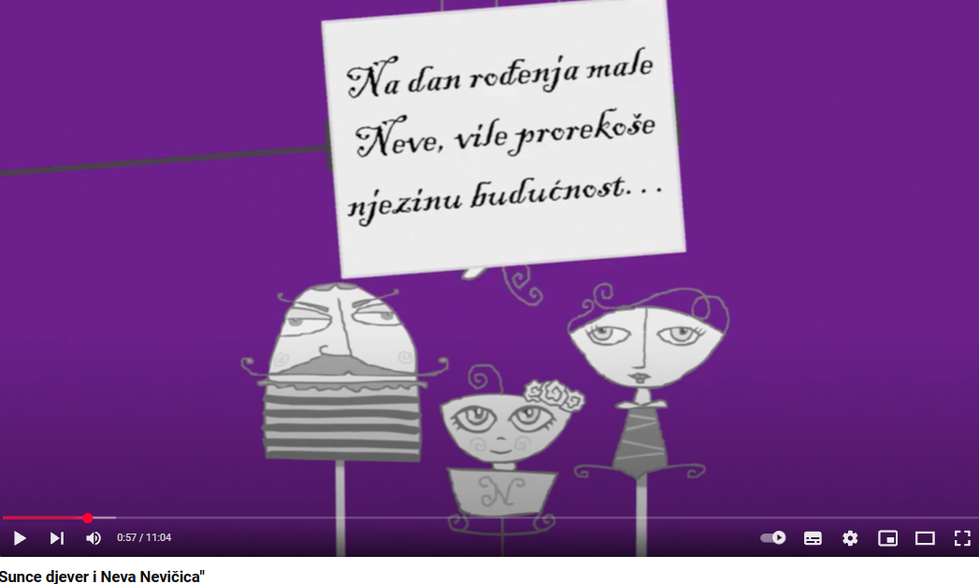

[**https://www.youtube.com/watch?v=mxviRFG7SCc**](https://www.youtube.com/watch?v=mxviRFG7SCc)

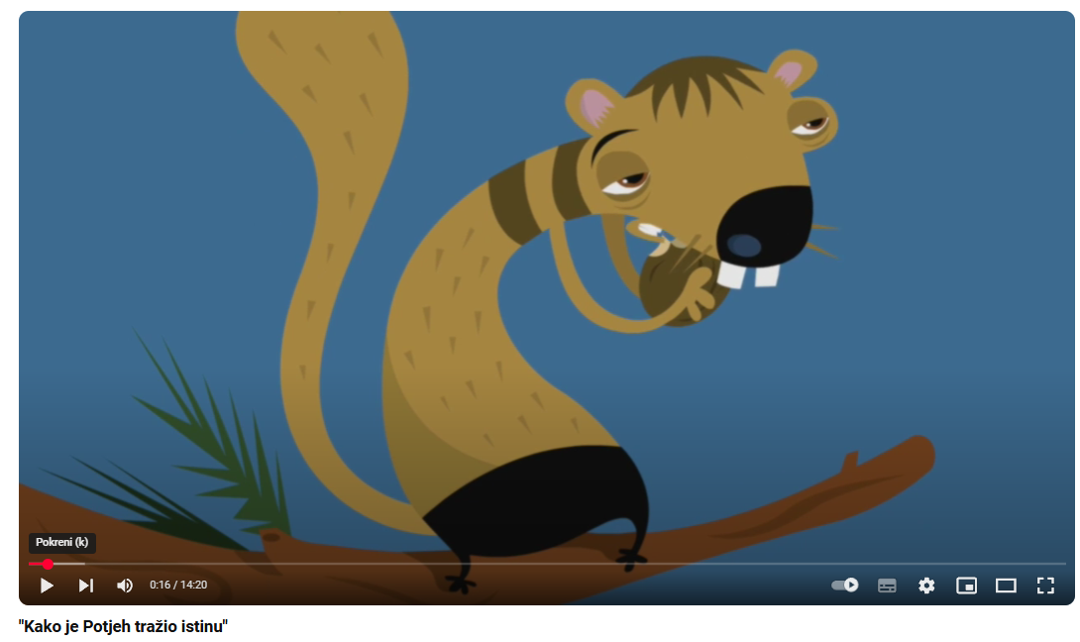**https://www.youtube.com/watch?v=0JZyigG6dn0**

**Slavko Kolar: „Breza“**

Slavko Kolar: „Breza“ Ante Babaja: „Breza“ (1967.)

<https://www.youtube.com/watch?v=7IwtCRxh_qE>

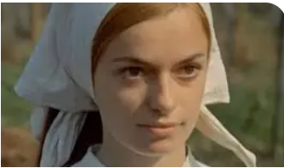

**BREZA: FILMSKI LISTIĆ**

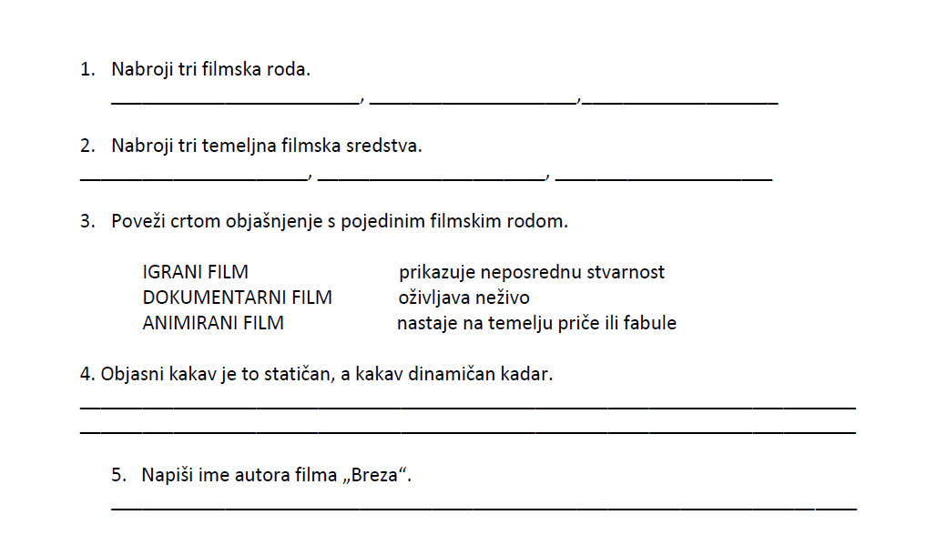

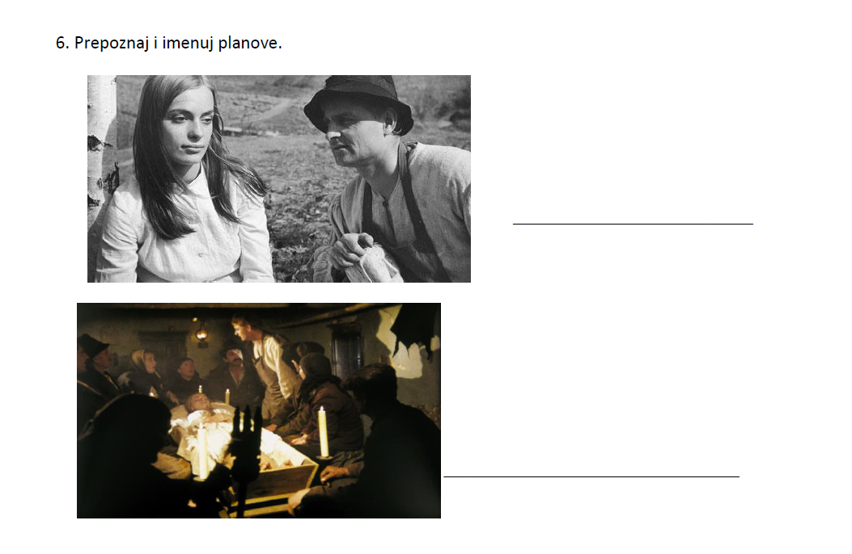

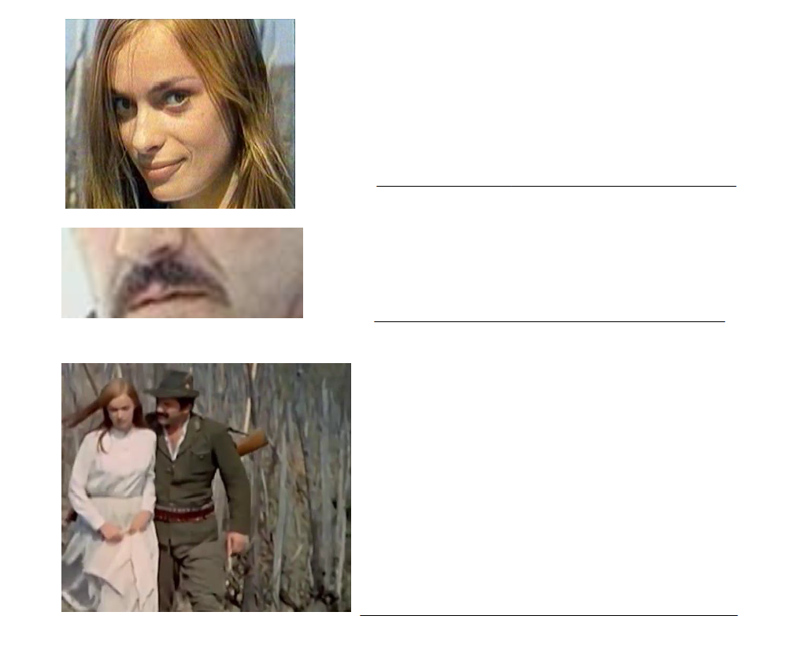

**„Romeo i Julija“: knjiga, film, balet**

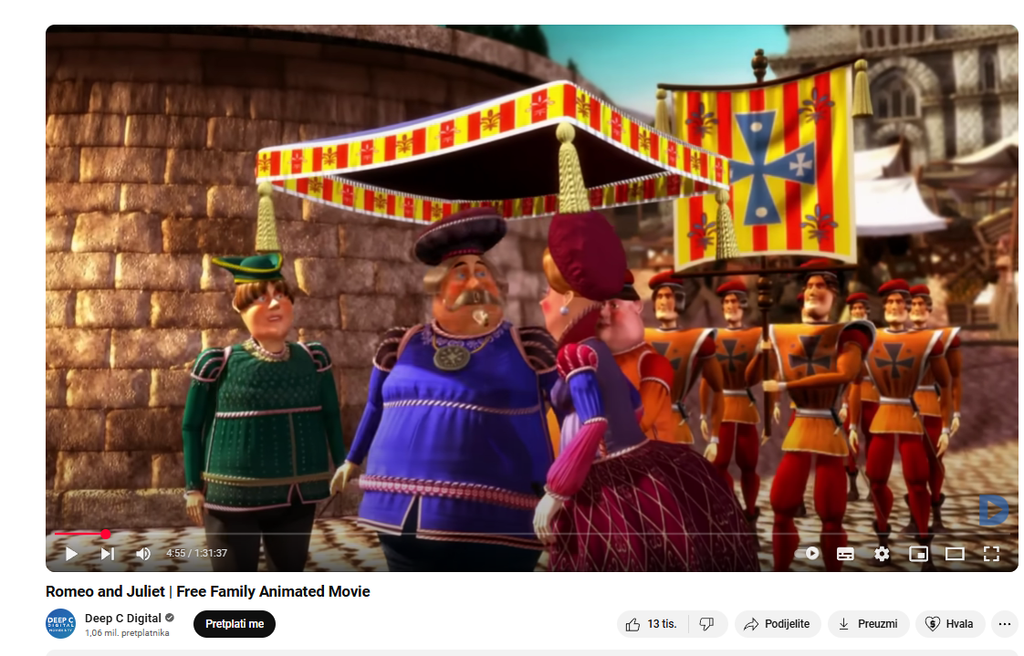

[**https://www.youtube.com/watch?v=kIqzT7HIu-I**](https://www.youtube.com/watch?v=kIqzT7HIu-I)

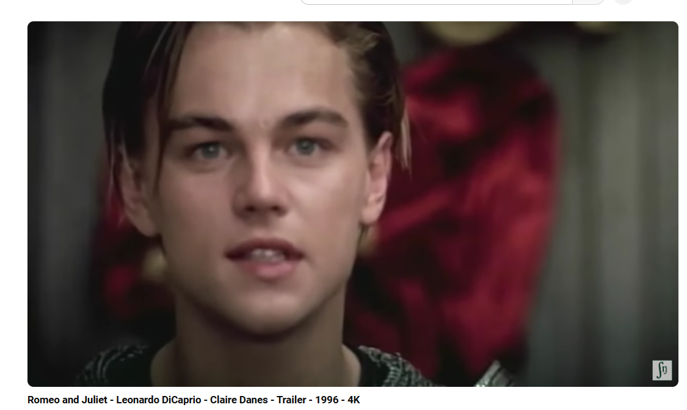

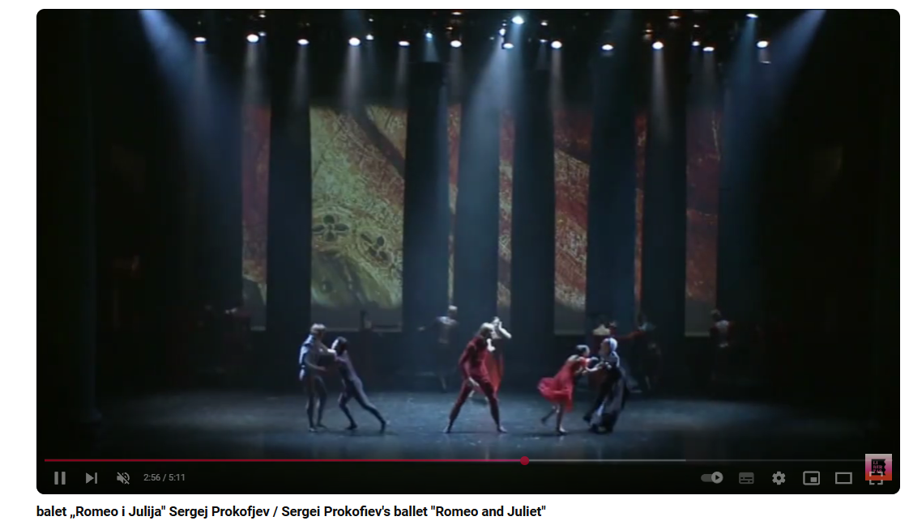

[**https://www.youtube.com/watch?v=6S6hSjISeOM**](https://www.youtube.com/watch?v=6S6hSjISeOM)

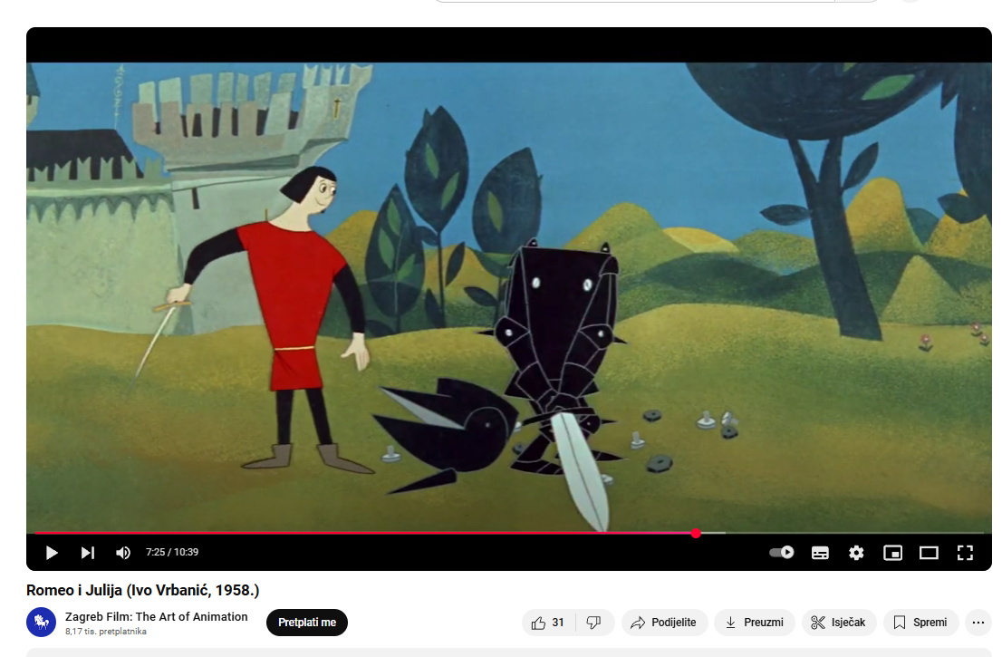

[**https://www.youtube.com/watch?v=wySPRPGf5_s**](https://www.youtube.com/watch?v=wySPRPGf5_s)

**FILMSKA OSMOSMJERKA**

